1 marks:

GRADE X
Question Bank (MATHEMATICS) Chapter-7 Co-ordinate Geometry

- If the distance between the points 𝐴(4, 𝑝) 𝑎𝑛𝑑 𝐵(1, 0) is 5 units then the value(s) of p is(are)
  - 4 only b) −4 only c) ±4 d) 0
- The distance between the points (𝑎 cos 𝜃 + 𝑏 sin 𝜃, 0) and (0, 𝑎 sin 𝜃 − 𝑏 cos 𝜃) is

  - 𝑎² + 𝑏² b) 𝑎² − 𝑏² c) √𝑎² + 𝑏² d) √𝑎² − 𝑏²
- The point P on x-axis equidistant from the points 𝐴(−1, 0), 𝐵(5, 0) is
  - (2, 0) b) (0, 2) c) (3, 0) d) (−3, 5)
- The point on x-axis which is equidistant from the points 𝐴(−2, 3), 𝐵(5, 4) is
  - (0, 2) b) (2, 0) c) (3, 0) d) (−2, 0)
- If the points 𝐴(4, 3) 𝑎𝑛𝑑 𝐵(𝑥, 5) are on the circle with centre 𝑂(2, 3) then the value of x is
  - 0 b) 1 c) 2 d) 3
- If points 𝐴(−3, 12), 𝐵(7, 6), 𝐶(𝑥, 9) are collinear then the value of x is
  - 2 b) 3 c) 4 d) 5
- The point which divides the line segment joining the points (8, −9)𝑎𝑛𝑑 (2, 3) in the ratio 1: 2 internally lies in the
  - I quadrant b) II quadrant c) III quadrant d) IV quadrant
- The coordinate of the point dividing the line segment joining the points
𝐴(1, 3), 𝐵(4, 6) in the ratio 2: 1 is
  - (5, 3) b) (3, 5) c) (4, 6) d) (6, 4)
- The line segment joining the points A(5, 3), B(-3, 11) is divided by the point C(3, 5) in the ratio
  - 1: 3 b) 3:1 c) 2: 3 d) 3: 2
- If the point 𝑃(6, 2) divides the line segment joining 𝐴(6, 5) 𝑎𝑛𝑑 𝐵(4, 𝑦) in the ratio 3: 1 then the value of y is
  - 1 b) 2 c) 3 d) 4

- The ratio in which the point (2, 𝑦) divides the join of (−4, 3) 𝑎𝑛𝑑 (6, 3) hence the value of y is
  - 2: 3, 𝑦 = 3 b) 3: 2, 𝑦 = 4 c) 3: 2, 𝑦 = 3 d) 3: 2, 𝑦 = 2
- If the point 𝑃(𝑘, 0) divides the line segment joining the points 𝐴(2, −2), 𝐵(−7, 4) in the ratio 1: 2 then the value of k is
  - 1 b) 2 c) -1 d) -2
- If the point 𝐶(𝑘, 4) divides the line segment joining two points 𝐴(2, 6), 𝐵(5, 1) in ratio 2: 3 then the value of k is

  - ⁵
16
  - 16
5
  - ⁹
5
  - ⁵
9

- C is the mid-point of PQ, if 𝑃(4, 𝑥), 𝐶(𝑦, −1), 𝑄(−2, 4) then x and y respectively are
  - -6 and 1 b) -6 and 2 c) 6 and -1 d) 6 and -2
- If 𝐴 (𝑚 , 5) is the mid-point of the line segment joining the points 𝑄(−6, 7), 𝑅(−2, 3)
3
then the value of m is
  - -12 b) -4 c) 12 d) -6
- If the centre of a circle is (3, 5) and end points of a diameter are (4, 7) 𝑎𝑛𝑑 (2, 𝑦)
then the value of y is
  - 3 b) -3 c) 7 d) 4
- If the mid-point of the line segment joining the points 𝐴(3, 4), 𝐵(𝑘, 6) is 𝑃(𝑥, 𝑦) and
𝑥 + 𝑦 − 10 = 0 the value of k will be
  - 4 b) 5 c) 6 d) 7
- Points 𝐴(3, 1), 𝐵(5, 1), 𝐶(𝑎, 𝑏) 𝑎𝑛𝑑 𝐷(4, 3) are vertices of a parallelogram. The values of a and b are
  - 6 and 3 b) 2 and 1 c) 4 and 2 d) none of these
- The co-ordinates of the point which is reflection of point (−3, 5) in x-axis are
  - (3, 5) b) (3, − 5) c) (−3, −5) d) (−3, 5)
- The centroid of the triangle whose vertices are (3, −7), (−8, 6) and (5, 10) is
  - (0, 9) b) (0, 3) c) (1, 3) d) (3, 5)
- If 𝑥 − 2𝑦 + 𝑘 = 0 is a median of the triangle whose vertices are at points
𝐴(−1, 3), 𝐵(0, 4), 𝐶(−5, 2) then the value of k is
  - 2 b) 4 c) 6 d) 8
- The coordinates of a point A on y-axis at a distance of 4 units from x-axis and below it are
  - (4, 0) b) (0, 4) c) (−4, 0) d) (0, −4)

- In what ratio, does x-axis divide the line segment joining the points
𝐴(3, 6), 𝐵(−12, −3)? [BOARD 2023]
  - 1:2 b) 1:4 c) 4:1 d) 2:1

- The distance between the points (0, 2√5) & (−2√5, 0) is [BOARD 2023]

  - 2√10 units b) 4√10 units c) 2√20 units d) 0

- The distance between the points 𝑃 (− 11
3
, 5)
, 𝑄
(− 2
3
, 5) is [BOARD 2023]

  - 6 units b) 4 units c) 2 units d) 3 units
- The end points of a diameter of a circle are (2, 4), (−3, −1). The radius of the circle is

[BOARD 2023]
  - 2√5 b) ⁵ √5 c) ⁵ √2 d) 5√2
2 2
- The coordinates of the vertex A of a rectangle ABCD whose three vertices are given as 𝐵(0, 0), 𝐶(3, 0) & 𝐷(0, 4) are [BOARD 2023]
  - (4, 0) b) (0, 3) c) (3, 4) d) (4, 3)
- The distance of the point (−1, 7) from x-axis is [BOARD 2023]

  - -1 b) 7 c) 6 d) √50
- The distance of the point (−6, 8) from origin is [BOARD 2023]
  - 6 b) -6 c) 8 d) 10
- The points (−4, 0), (4, 0), (0, 3) are the vertices of a [BOARD 2023]
  - Right triangle b) isosceles c) equilateral d) scalene
- The point of intersection of the line represented by 3𝑥 − 𝑦 = 3 and y-axis is given by

[BOARD 2023]
  - (0, −3) b) (0, 3) c) (2, 0) d) (−2, 0)
- The coordinates of the point where the line 2𝑦 = 4𝑥 + 5 crosses x-axis is

[BOARD 2023]
  - (0, − 5) b) (0, 5) c) (− 5 , 0) d) (− 5 , 0)
4 2 4 2
- If AB is a chord of a circle with centre at 𝑂(2, 3), where the coordinates of A and B are (4, 3), (𝑥, 5) respectively, then the value of x is [BOARD 2023]
  - 2 b) 3 c) 4 d) 5
- AD is a median of ∆𝐴𝐵𝐶 with vertices 𝐴(5, −6), 𝐵(6, 4)& 𝐶(0,0) length of AD is

[BOARD 2024]

  - √68 𝑢𝑛𝑖𝑡𝑠 b) 2√15 𝑢𝑛𝑖𝑡𝑠 c) √101 𝑢𝑛𝑖𝑡𝑠 d) 10 units

- The centre of a circle is at (2, 0). If one end of a diameter is at (6, 0) then the other end is at [BOARD 2024]
  - (0, 0) b) (4, 0) c) (−2, 0) d) (−6, 0)
- If the distance between the points (3, −5) and (𝑥, −5) is 15 units, then the values of x are [BOARD 2024]
  - 12, -18 b) -12, 18 c) 18, 5 d) -9, -12
- Point P divides the line segment joining the points 𝐴(4, −5) & 𝐵(1, 2) in the ratio 5:2. Co-ordinates of P are [BOARD 2024]
  - (5 , −3) b) (11 , 0) c) (13 , 0) d) (0, 13)
2 2 7 7 7
- XOYZ is a rectangle with vertices 𝑋(−3, 0), 𝑂(0, 0), 𝑌(0, 4)& 𝑍(𝑥, 𝑦). The length of its each diagonal is [BOARD 2024]
  - 5 units b) √5 units c) 𝑥² + 𝑦² units d) 4 units
- The distance between the points (𝑎 cos 𝜃, −𝑎 sin 𝜃) and ( 𝑎 sin 𝜃, 𝑎 cos 𝜃) is

[BOARD 2024]

  - a b) 𝑎√2 c) 0 d) 2a
- If the vertices of the parallelogram PQRS taken in order are
𝑃(3, 4), 𝑄(−2, 3) 𝑎𝑛𝑑 𝑅(−3, −2) then the co-ordinates of its fourth vertex S are

[BOARD 2024]
  - (−2, −1) b) (−2, −3) c) (2, −1) d) (1, 2)

Options for Assertion and Reasoning Questions:
    - Both assertion(A) and reason(R) are true and reason(R) is the correct explanation of assertion(A)
    - Both assertion(A) and reason(R) are true but reason(R) is not the correct explanation of assertion(A)
    - Assertion (A) is true but reason (R) is false
- Assertion (A) is false but reason (R) is true
- Assertion (A): The value of y is 6, for which the distance between the points
𝑃(2, −3) 𝑎𝑛𝑑 𝑄(10, 𝑦) is 10.
Reason (R): Distance between two given points 𝐴(𝑥₁, 𝑦₁)𝑎𝑛𝑑 𝐵(𝑥₂, 𝑦₂) is given 𝐴𝐵 =

√(𝑥₂ − 𝑥₁)² + (𝑦₂ − 𝑦₁)².
- Assertion (A): The point (−1, 6) divides the line segment joining the points
(−3, 10) 𝑎𝑛𝑑 (6, −8) in the ratio 2: 7 internally.

Reason (R): Given three points A, B and C form an equilateral triangle then 𝐴𝐵 =
𝐵𝐶 = 𝐴𝐶.
- Assertion (A): The point (0, 4) lies on y-axis.
Reason (R): The x coordinate on the point on y-axis is zero.
- Assertion (A): The point (3, 0) lies on x-axis.
Reason (R): The x coordinate on the point on y-axis is zero.
- Assertion (A): Point 𝑃(0, 2) is the point of intersection of y-axis with the line 3𝑥 + 2𝑦 = 4.
Reason (R): The distance of point 𝑃(0, 2) from x-axis is 2 units. [BOARD 2023]
- Assertion (A): If the points 𝐴(4, 3), 𝐵(𝑥, 5) lie on a circle with centre 𝑂(2, 3) then the value of x is 2.
Reason (R): Centre of a circle is the mid-point of each chord of the circle.

[BOARD 2023]
- Assertion (A): The point which divides the line segment joining the points
𝐴(1, 2) & 𝐵(−1, 1) internally in the ratio 1:2 is (−1 , 5).
3 3
Reason (R): The coordinates of the point which divides the line segment joining the
points 𝐴(𝑥 , 𝑦 ) & 𝐵(𝑥 , 𝑦 ) in the ratio 𝑚 : 𝑚 are (𝑚1𝑥2+𝑚2𝑥1 , 𝑚1𝑦2+𝑚2𝑦1).

1 1 2 2
1 2 𝑚1+𝑚2
𝑚1+𝑚2

[BOARD 2024]

- Assertion (A): Mid-point of a line segment divides the line segment in the ratio 1:1. Reason (R): The ratio in which the point (−3, 𝑘) divides the line segment joining the points (−5, 4) & (−2, 3) is 1:2. [BOARD 2024]

2 marks:
- What is the distance of the point 𝑃(3, 4) from x-axis?
- The ordinate of a point A on y-axis is 5 and B has coordinates (−3, 1). Find the length of AB?
- If the distance between the points 𝐴(4, 𝑝), 𝐵(1, 0) is 5 units then what are the values of p?
- If 𝐴(5, 2), 𝐵(2, −2)𝑎𝑛𝑑 𝐶(−2, 𝑡) are the vertices of a right angled triangle with ∠𝐵 = 90°
then find the value of t.

- If three points (0,0), (3, √3) 𝑎𝑛𝑑 (3, 𝜆) form an equilateral triangle, then what is the value of 𝜆?
- Find the coordinate of the point dividing the line segment joining the points
𝐴(1, 3) 𝑎𝑛𝑑 𝐵(4, 6) in the ratio 2: 1?

- The x coordinate of a point P is twice its y coordinate. If P is equidistant from
𝑄(2, −5), 𝑅(−3, 6), find the coordinates of P.
- If the point 𝑃(𝑥, 𝑦) is equidistant from the points 𝑄(𝑎 + 𝑏, 𝑏 − 𝑎), 𝑅(𝑎 − 𝑏, 𝑎 + 𝑏) then prove that 𝑏𝑥 = 𝑎𝑦.
- Find the ratio in which the point 𝑃 (3 , 5 ) divides the line segment joining the points

𝐴 (1 , 3) 𝑎𝑛𝑑 (2, −5).
4 12

2 2
- If 𝐴 (𝑚 , 5) is the mid-point of the line segment joining the points 𝑄(−6, 7), 𝑅(−2, 3)
3
then what is the value of m?
- The mid-point of the line segment AB is 𝑃(0, 4), if the coordinates of B are (−2, 3)
then find the coordinates of A.
- If the points 𝐴(4, 3), 𝐵(𝑥, 5) are on the circle with centre 𝑂(2, 3) then what is the value of x?
- If the centre of a circle is (3, 5) and end points of a diameter are (4, 7) 𝑎𝑛𝑑 (2, 𝑦).
What is the value of y?
- Show that the points (−2, 3), (8, 3), (6, 7) are the vertices of a right angled triangle.

[BOARD 2023]

- Show that the points (−3, −3), (3, 3), (−3√3, 3√3) are the vertices of an equilateral triangle. [BOARD 2023]
- Prove that 𝐴(4, 3), 𝐵(6, 4), 𝐶(5, 6), 𝐷(3, 5) are the vertices of a square. [BOARD 2023]
- Show that 𝐴(0, −1), 𝐵(6, 7), 𝐶( −2, 3), 𝐷(8, 3) are the vertices of a rectangle ABCD.

[BOARD 2023]
- Show that the points 𝐴(6, 4), 𝐵(5, −2), 𝐶(7, −2) are the vertices of an isosceles triangle. Also, find the length of the median through point A. [BOARD 2023]
- The line segment joining the points 𝐴(4, −5), 𝐵(4, 5) is divided by the point P such that 𝐴𝑃: 𝐴𝐵 = 2: 5. Find the coordinates of P. [BOARD 2023]
- The point 𝑃(𝑥, 𝑦) is equidistant from points 𝐴(5, 1), 𝐵(1, 5). Prove that 𝑥 = 𝑦.

[BOARD 2023]
- Find the ratio in which y-axis divides the line segment joining the points
(5, −6), (−1, −4). [BOARD 2023]
- Find the ratio in which line 𝑦 = 𝑥 divides the line segment joining the points
(6, −3), (1, 6). [BOARD 2023 & BOARD 2024]

- A line intersects y-axis and x-axis at point P and Q respectively. If 𝑅(2, 5) is the mid-point of line segment PQ, then find the coordinates of P and Q. [BOARD 2023]
- Find the points on the x-axis, each of which is at a distance of 10 units from the point 𝐴(11, −8). [BOARD 2023]
- Find the ratio in which the point (−1, 𝑘) divides the line segment joining the points
(−3, 10), (6, −8). Also find the value of k. [BOARD 2023]
- If 𝐴(−2, −1), 𝐵(𝑎, 0), 𝐶(4, 𝑏), 𝐷(1, 2) are the vertices of a parallelogram ABCD then find the values of a and b. [BOARD 2023]
- The three vertices of a parallelogram ABCD taken in order, are 𝐴(−1, 0), 𝐵(3, 1),
𝐶(2, 2). Find the coordinates of the fourth vertex D. [BOARD 2023]
- Find the type of triangle ABC formed whose vertices are 𝐴(1, 0), 𝐵(−5, 0) & 𝐶(−2, 5).

[BOARD 2024]
- 𝐴(3, 0), 𝐵(6, 4), 𝐶(−1, 3) are vertices of a triangle ABC. Find length of its median BE.

[BOARD 2024]
- Find a relation between x and y such that the point 𝑃(𝑥, 𝑦) is equidistant from the points 𝐴(7, 1)𝑎𝑛𝑑 𝐵(3, 5). [BOARD 2024]
- Points 𝐴(−1, 𝑦) & 𝐵(5, 7) lie on a circle 𝑂(2, −3𝑦) such that AB is a diameter of the circle. Find the value of y. Also, find the radius of the circle. [BOARD 2024]

3 marks:

- If the distance of 𝑃(𝑥, 𝑦) from 𝐴(6, 2)𝑎𝑛𝑑 𝐵(−2, 6) are equal. Prove that 𝑦 = 2𝑥.
- Show that 𝐴(−1, 0), 𝐵(3, 1), 𝐶(2, 2) 𝑎𝑛𝑑 𝐷(−2, 1) are the vertices of a parallelogram.
- Prove that the diagonals of a rectangle ABCD with vertices 𝐴(2, −1), 𝐵(5, −1), 𝐶(5, 6)
and 𝐷(2, 6) are equal and bisect each other.
- In the given figure, ∆𝐴𝐵𝐶 is an equilateral triangle of side 3 units. Find the co- ordinates of the other two vertices.
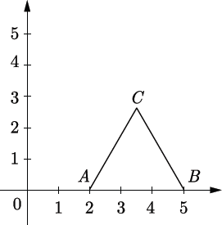

- Find the ratio in which 𝑃(4, 𝑚) divides the segment joining the points
𝐴(2, 3)𝑎𝑛𝑑 𝐵(6, −3). Hence find m.
- Find the ratio in which the line 2𝑥 + 3𝑦 − 5 = 0 divides the line segment joining the points (8, −9)𝑎𝑛𝑑 (2, 1). Also find the coordinates of the point of division.
- If the point 𝐶(−1, 2) divides internally the line segment joining the points
𝐴(2, 5), 𝐵(𝑥, 𝑦) in the ratio 3: 4. Find the coordinates of B.
- If the point 𝐶(−1, 2) divides internally the line segment joining the points
𝐴(2, 5), 𝐵(𝑥, 𝑦) in the ratio 3: 4 then find the value of 𝑥² + 𝑦².
- If the co-ordinates of points A and B are (−2, −2)𝑎𝑛𝑑 (2, −4) respectively. Find the

coordinates of P such that
𝐴𝑃 =
³ 𝐴𝐵
7
where P lies on the line segment AB.

- Find the coordinates of the points of trisection of the line segment joining the points 𝐴(1, −2)𝑎𝑛𝑑 𝐵(−3, 4).
- The vertices of ∆𝐴𝐵𝐶 are 𝐴(6, −2), 𝐵(0, −6), 𝐶(4, 8). Find the co-ordinates of mid- points of AB, BC and AC.
- If (𝑎, 𝑏) is the mid-point of the line segment joining the points 𝐴(10, −6)𝑎𝑛𝑑 𝐵(𝑘, 4)
and 𝑎 − 2𝑏 = 18 then find the value of k and the distance AB.
- The coordinates of the vertices of ∆𝐴𝐵𝐶 are 𝐴(7, 2), 𝐵(9, 10) 𝑎𝑛𝑑 𝐶(1, 4). If E and F are

the mid-points of AB and AC respectively. Prove that
𝐸𝐹 =
¹ 𝐵𝐶.
2

- If (−5, 3) & (5, 3) are two vertices of an equilateral triangle then find co-ordinates of the third vertex given that origin lies inside the triangle. (𝑈𝑠𝑒 √3 = 1.7)

[BOARD 2023]
- The centre of a circle is (2𝑎, 𝑎 − 7). Find the values of ‘a’ if the circle passes through the point (11, −9). Radius of the circle is 5√2 𝑐𝑚. [BOARD 2023]
- If 𝑄(0, 1) is equidistant from 𝑃(5, −3) & 𝑅(𝑥, 6) find the values of x. [BOARD 2023]
- Find the ratio in which the line segment joining the points 𝐴(6, 3), 𝐵(−2, −5) is divided by x-axis. [BOARD 2023]
- Find the ratio in which the point (8 , 𝑦) divides the line segment joining the points
5
(1, 2)& (2, 3). Also find the value of y. [BOARD 2024]
- ABCD is a rectangle formed by the points 𝐴(−1, −1), 𝐵(−1, 6), 𝐶(3, 6), 𝐷(3, −1). P, Q, R and S are mid-points of sides AB, BC, CD & DA respectively. Show that diagonals of the quadrilaterals PQRS bisect each other. [BOARD 2024]

- Find the ratio in which the line segment joining the points 𝐴(5, 3) & 𝐵(−1, 6) is divided by y axis. [BOARD 2024]
- 𝑃(−2, 5) & 𝑄(3, 2) are two points. Find the coordinates of the point R on line segment PQ such that 𝑃𝑅 = 2𝑄𝑅. [BOARD 2024]
- In what ratio does the x-axis divides the line segment joining the points
(2, −3) & (5, 6)? Also find the coordinates of the point of intersection. [BOARD 2024]
- Find the length of the median AD of ∆𝐴𝐵𝐶 having vertices 𝐴(0, −1), 𝐵(2, 1) & 𝐶(0, 3).

[BOARD 2024]
- Show that 𝐴(6, 4), 𝐵(5, −2) 𝑎𝑛𝑑 𝐶(7, −2) are the vertices of an isosceles triangle.

[BOARD 2024]

5 marks:

- Show that the points (𝑎, 𝑎), (−𝑎, −𝑎), (−√3𝑎, √3𝑎) are the vertices of an equilateral triangle.
- Show that the points 𝑃(2, −1), 𝑄(3, 4), 𝑅(−2, 3) 𝑎𝑛𝑑 𝑆(−3, −2) are vertices of a rhombus but not a square.
- Point A lies on the line segment XY joining 𝑋(6, −6), 𝑌(−4, −1) in such a way that
^{𝑋𝐴} = 2. If point A also lies on the line 3𝑥 + 𝑘(𝑦 + 1) = 0 find the value of k.
𝑋𝑌 5
- The ratio in which the line 𝑥 − 3𝑦 = 0 divides the line segment joining the points
(−2, −5)𝑎𝑛𝑑 (6, 3). Find the coordinates of the point of intersection.
- Find the ratio in which the y axis divides the line segment joining the points
(−1, −4), (5, −6). Also find the coordinates of the point of intersection.
- Find the ratio in which the point (−3, 𝑘) divides the line segment joining the points
(−5, −4) 𝑎𝑛𝑑 (−2, 3). Also find the value of k.
- Find the ratio in which the point 𝑃 (3 , 5 ) divides the line segment joining the point

𝐴 (1 , 3) and (2, −5).
4 12

2 2
- If the midpoint of the line segment joining 𝐴 (𝑥 , 𝑦+1) 𝑎𝑛𝑑 𝐵(𝑥 + 1, 𝑦 − 3) is 𝐶(5, −2)
2 2
find the value of x and y.

Case Based Questions:
- A tiling or tessellation of a flat surface is the covering of a plane using one or more geometric shapes, called tiles, with no overlaps and no gaps. Historically, tessellations were used in ancient Rome and in Islamic art. You may find

tessellation patterns on floors, walls, paintings etc. Shown below is a tiled floor in the archaeological Museum of Seville, made using squares, triangles and hexagons. A craftsman thought of making a floor pattern after being inspired by the above design. To ensure accuracy in his work, he made the pattern on the Cartesian plane. He used regular octagons, squares and triangles for his floor tessellation pattern
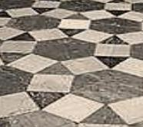
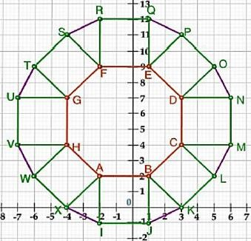

Use the above figure to answer the questions that follow:
  - What is the length of the line segment joining points B and F? 1
  - The centre ‘Z’ of the figure will be the point of intersection of the diagonals of quadrilateral WXOP. Then what are the coordinates of Z? 1
  - What are the coordinates of the point on y axis equidistant from A and G? 2

OR
What is the area of Trapezium AFGH? 2
- Tharunya was thrilled to know that the football tournament is fixed with a monthly timeframe from 20th July to 20th August 2023 and for the first time in the FIFA Women’s World Cup’s history, two nations host in 10 venues. Her father felt that the game can be better understood if the position of players is represented as points on a coordinate plane.
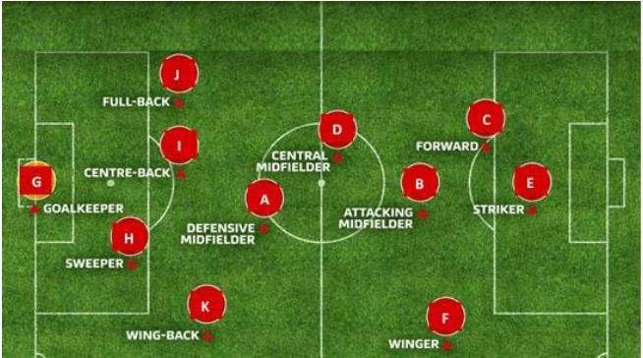

  - At an instance, the midfielders and forward formed a parallelogram. Find the position of the central midfielder (D) if the position of other players who formed the parallelogram are :- A(1,2), B(4,3) and C(6,6). 1
  - Check if the Goal keeper G(-3,5), Sweeper H(3,1) and Wing-back K(0,3) fall on a same straight line. 2

OR
Check if the Full-back J(5,-3) and centre-back I(-4,6) are equidistant from forward C(0,1) and if C is the mid-point of IJ. 2
  - If Defensive midfielder A(1,4), Attacking midfielder B(2,-3) and Striker E(a,b) lie on the same straight line and B is equidistant from A and E, find the position of E. 1
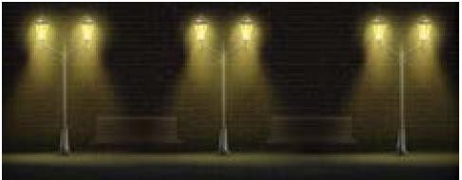
- Resident Welfare Association (RWA) of a Gulmohar Society in Delhi have installed three electric poles A, B and C in a society’s common park. Despite these three poles, some parts of the park are still in dark. So, RWA decides to have one more electric pole D in the park.

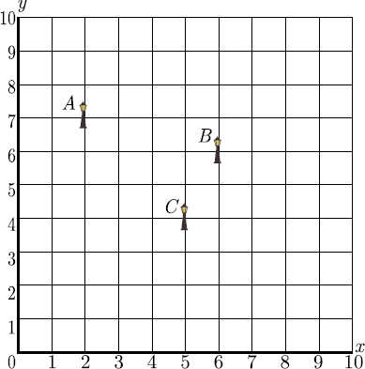
The park can be modelled as a coordinate systems given below.
  - What is the distance of the pole B from the corner O of the park? 1
  - Find the position of the fourth pole D so that four points A, B C and D form a parallelogram. 1
  - What is the distance between poles A and C? 2

OR
What is the distance between poles B and D? 2

- Satellite Images: Satellite images are images of Earth collected by imaging satellites operated by governments and businesses around the world. Satellite imaging companies sell images by licensing them to governments and businesses such as Apple Maps and Google Maps. It should not be confused for astronomy images collected by space telescope.
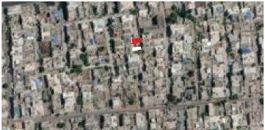
Barun lives in Jaipur in Vaishali. Satellite image of his colony is shown in given figure. In this view, his house is pointed out by a flag, which is situated at the point of intersection of x and y - axes. If he goes 2 cm east and 3 cm north from the house, then he reaches to a grocery store, If he goes 4 cm west and 6 cm south from the house, then he reaches to his office. If he goes 6 cm east and 8 cm south from the house, then he reaches to a food court. If he goes 6 cm west and 8 cm north from the house, he reaches to a his kid’s school.
Based on the above information, answer the following questions.
  - Find the distance between grocery store and food court. 1
  - Find the distance of the school from the house. 1
  - If the grocery store and office lie on a line, what is the ratio of distance of house from grocery store to that from office? 2

OR
What shape is formed by the coordinates of positions of school, grocery store, food court and office? 2


- Morning assembly is an integral part of the school’s schedule. Almost all the schools conduct morning assemblies which include prayers, information of latest happenings, inspiring thoughts,
speech, national anthem, etc. A good school is always particular about their morning assembly schedule. Morning assembly is important for a child’s development. It is essential to understand that morning assembly is not just about standing in long queues and singing prayers or national anthem, but it’s something beyond just

prayers. All the activities carried out in morning assembly by the school staff and students have a great influence in every point of life. The positive effects of attending school assemblies can be felt throughout life.
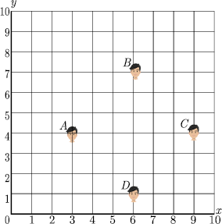
Have you noticed that in school assembly you always stand in row and column and this make a coordinate system. Suppose a school have 100 students and they all assemble in prayer in 10 rows as given below.

Here A, B, C and D are four friend Amar, Bharat, Colin and Dravid.
  - What is the distance between A and B? 1
  - What is the distance between C and D? 1
  - What is the distance between A and C? 2

OR
What is the distance between D and B? 2
- Carpooling: It is the sharing of car journeys so that more than one person travels in a car, and prevents the need for others to have to drive to a location themselves. By having more people using one vehicle, carpooling reduces each person’s travel costs such as: fuel costs, tolls, and the stress of driving. Carpooling is also a more environmentally friendly and sustainable way to travel as sharing journeys reduces air pollution, carbon emissions, traffic congestion on the roads, and the need for parking spaces.

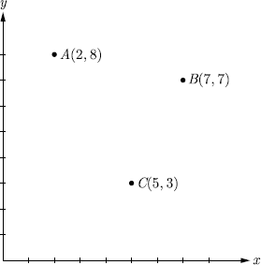
Three friends Amar, Bandhu and Chakradev lives in societies represented by the points A, B and C respectively. They all work in offices located in a same building represented by the point O. Since they all go to same building every day, they

decided to do carpooling to save money on petrol. Based on the above information, answer the following questions.
  - Which society is nearest to the office? 1
  - What is the distance between A and C? 1
  - Find the least distance between AB, OA and BC? 2

OR
If Bandhu and Chakradev planned to meet at a club situated at the mid- point of the line joining the points B and C , find the coordinates of this point. 2

- To conduct sports day activities, in a rectangular shaped school ground ABCD, lines have been drawn with chalk powder at a distance of 1 m each. 100 flower pots have been placed at a distance of 1 m from each other along AB, as shown in
figure. Nishtha runs ¹𝑡ℎ of the distance AB on the 2nd line and posts a green flag.
4
Suman runs ¹𝑡ℎof the distance AB on the 8th line and posts a red flag.
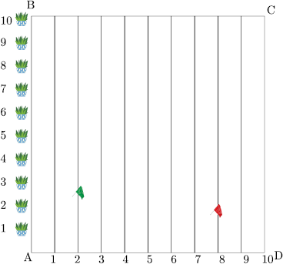
5
  - What is the position of green flag? 1
  - What is the position of red flag? 1
  - What is the distance between both the flags? 2

OR
What is the distance of red flag from point A? 2
- A garden is in the shape of rectangle. Gardener grew sapling of Ashoka tree on the boundary of garden at the distance of 1 meter from each other. He want to decorate the garden with rose plants. He choose triangular region inside the park to grow rose plants. On the above situation, gardener took help from the students of class 10th. They made a chart for it which looks as the above figure.

[BOARD 2024]

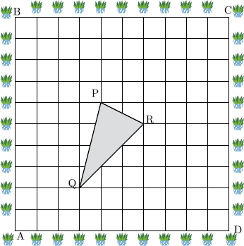

  - If A is taken as origin, what are the coordinates of triangle PQR? 1
  - Find out if ∆𝑃𝑄𝑅 is an isosceles triangle. 1
  - Find distances PQ & QR? 2

OR
Find the coordinates of the point which divides the line segment joining the points P and R in the ratio 2:1 internally. 2
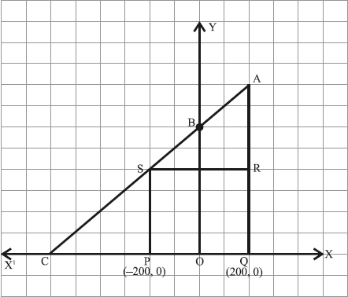
- Jagdish has a field which is in the shape of a right angled triangle AQC. He wants to leave a space in the form of a square PQRS inside the field for growing wheat and the remaining for growing vegetables (as shown in the figure). In the field, there is a pole marked as O. [BOARD 2023]
Based on the above information, answer the following questions:
  - Taking O as origin, coordinates of P are (−200, 0) and of Q are (200, 0). PQRS being a square, what are the coordinates of R and S? 1
  - What is the area of square PQRS? 2

OR
What is the length of diagonal PR in square PQRS? 2
  - If S divides CA in the ratio K:1, what is the value of K, where point A is
(200, 800)? 1

- Ryan, from a very young age, was fascinated by the twinkling of stars and the vastness of space. He always dreamt of becoming an astronaut one day. So he started to sketch his own rocket designs on the graph sheet. One such design is given below: [BOARD 2024]
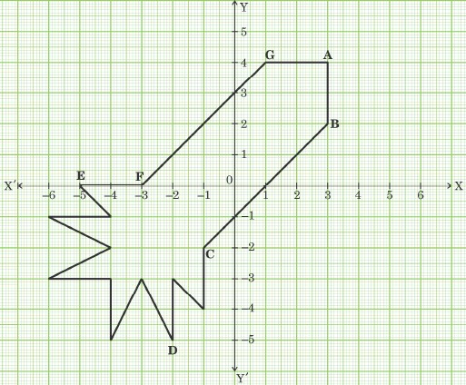
Based on the above, answer the following questions:
  - Find the mid-point of the segment joining F and G. 1
  - What is the distance between the points A and C? 2

OR
Find the coordinates of the point which divides the line segment joining the points A and B in the ratio 1:3 internally. 2
  - What are the coordinates of the point D? 1

